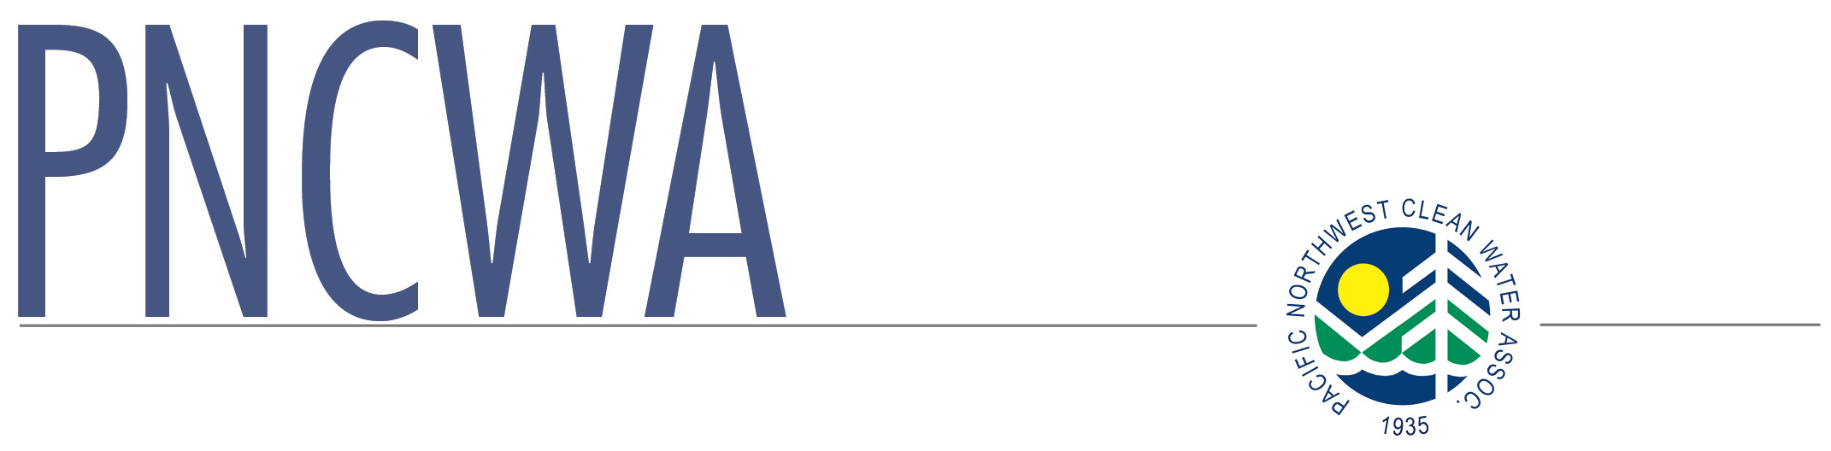
Burke Award application
Pacific Northwest Clean Water Association

PO Box 100
Hansen, ID 83334

www.pncwa.org
208.455.8381

You may use the online form instead of this fillable form if you wish, at www.pncwa.org.

INSTRUCTIONS:
A. Fill out the application. Materials submitted will not be returned.
B. All required information should be for the period January through December for the year previous to the year in which the application is being made. If you are applying in 2015, the info requested should be from 2014, etc.
C. Submit application by deadline listed at www.pncwa.org
D. If you have any questions, please call the PNCWA office at 208.455.8381
E. The award is based on your application and what is submitted. This will be a very difficult task to determine the
winner, so what information you can provide will be of benefit to the safety committee as well the applicant. There
is no need to send large plans, manuals or documents, just a copy of the cover and table of contents.

GENERAL INFORMATION:
Name of Plant:
Address:
Average Flow:
Design Flow:
Number of Employees in:
Operations: Collections: P lant Maintenance: Lab:

SAFETY RECORD:
Total number of lost time days in previous year ( ) due to injuries: days
Total number of reportable accidents

REPORTING
Do you have a formal accident review procedure?
Yes No
Briefly describe how your accident review procedure works.
Provide copies if possible:

SAFETY PROGRAM
Do you hold regularly scheduled safety meetings?
Yes No
If yes, describe type, frequency, and how recorded and filed.

Who coordinates the safety program?
What type of accident record keeping does your organization maintain? Briefly describe and/or submit example.

What type of emergency communication does your plant have if the telephone system is down?

Describe safety programs that you feel are unique to your organization. Provide documentation if possible.

SAFETY TRAINING
Who provides training and where?
Frequency of training sessions? Provide documentation.
Examples of topics covered:
How many of your employees are CPR certified?
Is CPR training provided at agency expense and time? Yes No
Has your agency made up a safety manual? Yes No
Do you have in-house contingency plans for major disasters? Yes No
If so please submit a sample of the contingency plans

How often does your agency meet with other local agencies such as fire and paramedics to coordinate emergency response?
How often does your agency hold response drills?

Due date: See www.pncwa.org. Please use online form at www.pncwa.org or submit this form and additional documentation electronically to awards@pncwa.org or mikerainey@pncwa.org. Mailing address if necessary is P.O. Box 100, Hansen, ID 83334

